Cell Respiration – Converting Chemical Energy into ATP (Energy for Cells)

Every move you make — every blink, every heartbeat, every thought — requires energy. That energy does not come directly from the food you eat. Instead, your cells must convert the chemical energy stored in glucose into a form they can actually use. This process happens constantly, in every cell of your body, whether you are sleeping, running, studying, or digesting lunch. Yet most people never think about the remarkable molecular machinery that keeps them alive.
Cellular respiration is the process that unlocks the energy stored in food and packages it into ATP — the universal energy currency of cells. Understanding cellular respiration means understanding where your energy really comes from, how your body powers itself, and why you need oxygen to live.
This reading material explores the steps of aerobic respiration (glycolysis, acetyl CoA formation, the citric acid cycle, the electron transport chain, and chemiosmosis), the structure and function of mitochondria, the differences between aerobic and anaerobic respiration, and how cellular respiration provides energy for everyday activities such as running, thinking, and digesting food.

Part 1: What Is Cell Respiration and Why Does It Matter?

Definition of Cell Respiration
Cell respiration is the chemical reaction that converts chemical energy (stored in glucose and other organic molecules) into usable forms of energy (ATP). It is the process by which cells harvest energy from food.

The Central Idea: Glucose Contains Stored Energy
When you eat food, your digestive system breaks down complex molecules into glucose (C₆H₁₂O₆). Glucose contains chemical energy stored in its bonds. Cellular respiration gradually breaks these bonds, captures the released energy, and uses it to make ATP. The overall process is the opposite of photosynthesis.

The Overall Equation for Aerobic Respiration
C₆H₁₂O₆ + 6 O₂ → 6 CO₂ + 6 H₂O + ATP (energy)
Compare this to photosynthesis:
Process | Equation
Photosynthesis | 6 CO₂ + 6 H₂O + Light → C₆H₁₂O₆ + 6 O₂
Cellular respiration | C₆H₁₂O₆ + 6 O₂ → 6 CO₂ + 6 H₂O + ATP
They are exact opposites. Photosynthesis stores energy. Cellular respiration releases it.

Why Cell Respiration Matters
Aspect | Explanation
Energy for life | All cellular activities (growth, repair, movement, transport, signaling)  require ATP from cellular respiration
ATP as energy carrier | ATP captures and releases energy in small, usable amounts
Oxygen dependence | Most organisms need oxygen for maximum ATP production; without it,  far less energy is captured
Metabolism | Cellular respiration is the central pathway of energy metabolism in  eukaryotic cells

Part 2: The Importance of ATP as the Energy Carrier and the Role of Enzymes

ATP: The Energy Currency of the Cell
ATP (adenosine triphosphate) is the molecule that cells use to transfer energy from energy-releasing reactions to energy-requiring processes. It is often called the energy currency of the cell.
Feature | Explanation
Structure | ATP has three phosphate groups attached to adenosine (adenine + ribose)
Energy storage | The bonds between phosphate groups are high-energy bonds
How it works | When a cell needs energy, it breaks the last phosphate bond (ATP → ADP + Pᵢ),  releasing energy
Recycling | ADP (adenosine diphosphate) can be recharged back into ATP during cellular  respiration

The Role of Enzymes in Cellular Respiration
Enzymes are biological catalysts that speed up chemical reactions without being consumed. They are essential for cellular respiration because the breakdown of glucose would be too slow and uncontrolled without them.
Role of Enzymes | Explanation
Lower activation energy | Enzymes reduce the energy needed to start each reaction in  the pathway
Specificity | Each enzyme catalyzes only one specific step (e.g., hexokinase  phosphorylates glucose)
Regulation | Enzymes are controlled by feedback inhibition to match ATP supply  with demand
Temperature and pH sensitivity | Enzymes work best at optimal conditions (body temperature, neutral  pH for most)

Part 3: The Structure of Mitochondria and Its Relationship to Function

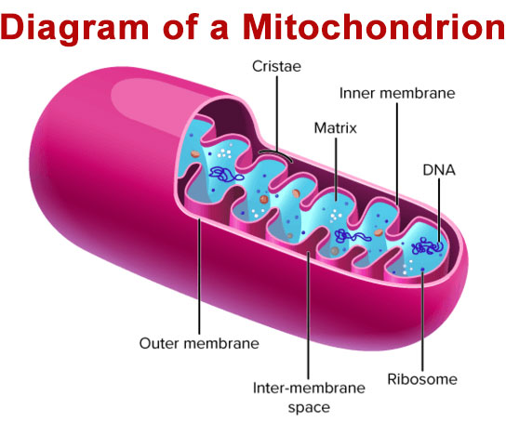

How Mitochondrial Structure Relates to Function
Structure | Description | How It Supports Function
Outer membrane | Smooth and porous | Allows small molecules (pyruvate, ADP, ATP)  to pass through easily
Inner membrane | Folded into cristae; highly selective | Large surface area for electron transport chain  and ATP synthase enzymes
Cristae (folds) | Finger-like projections of inner membrane | Increases surface area → more space for ETC  proteins → more ATP production
Matrix | Fluid-filled inner compartment | Contains enzymes for pyruvate processing  and citric acid cycle (Krebs cycle)
Intermembrane space | Space between outer and inner membranes | Small space where protons accumulate during  electron transport, creating a gradient for chemiosmosis
Double membrane structure | Two separate membranes | Allows compartmentalization; different  processes occur in different regions

Summary: Structure-Function Relationship
Function of Mitochondria | Structural Feature That Enables It
Pyruvate processing and citric acid cycle | Enzymes located in the matrix
Electron transport chain | Proteins embedded in inner membrane
Proton gradient for chemiosmosis | Impermeable inner membrane + small intermembrane space
High ATP production | Folded cristae (large surface area for ETC and ATP synthase)

Part 4: The Steps in Aerobic Respiration
Aerobic respiration occurs in four main stages: glycolysis, formation of acetyl coenzyme A, the citric acid cycle, and the electron transport chain with chemiosmosis.

Stage 1: Glycolysis
Glycolysis occurs in the cytoplasm and does not require oxygen. It is the first step of both aerobic and anaerobic respiration.
Feature | Explanation
Location | Cytoplasm (cytosol)
Oxygen required? | No (anaerobic)
Input | One molecule of glucose (6 carbons)
Output (per glucose) | 2 pyruvate (3 carbons each), 2 ATP (net gain), 2 NADH
Key points | Glucose is split into two three-carbon molecules; small amount of ATP  captured
Enzymes involved | Hexokinase, phosphofructokinase, pyruvate kinase, and others

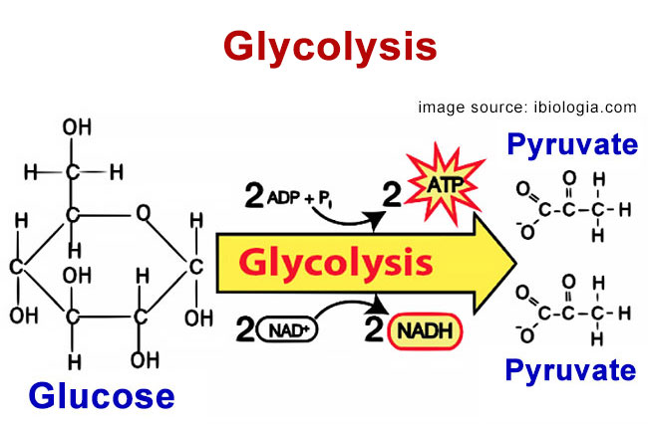

Stage 2: Formation of Acetyl Coenzyme A
Before entering the citric acid cycle, pyruvate must be converted into acetyl CoA. This step connects glycolysis to the rest of aerobic respiration.
Feature | Explanation
Location | Mitochondrial matrix
Oxygen required? | Yes (indirectly; this step only occurs in aerobic conditions)
Input (per glucose) | 2 pyruvate (from glycolysis)
Output (per glucose) | 2 acetyl CoA, 2 CO₂, 2 NADH
Key points | Each pyruvate loses one carbon as CO₂; remaining two-carbon acetyl  group attaches to coenzyme A
Enzymes involved | Pyruvate dehydrogenase complex

Stage 3: Citric Acid Cycle (Krebs Cycle)
The citric acid cycle completes the breakdown of glucose by oxidizing acetyl CoA to carbon dioxide.
Feature | Explanation
Location | Mitochondrial matrix
Oxygen required? | Yes (indirectly; cycle requires NAD⁺ and FAD, which are regenerated by  electron transport chain)
Input (per glucose) | 2 acetyl CoA (each enters separately)
Output (per glucose) | 4 CO₂, 6 NADH, 2 FADH₂, 2 ATP
Key points | Each turn of the cycle processes one acetyl CoA; two turns per glucose  molecule; carbon atoms are released as CO₂
Enzymes involved | Citrate synthase, isocitrate dehydrogenase, succinate dehydrogenase,  and others

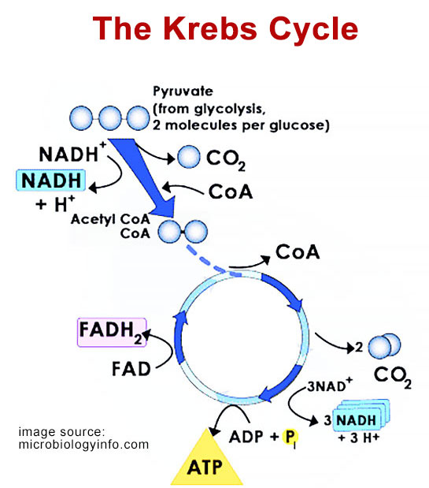

Stage 4: Electron Transport Chain and Chemiosmosis
The electron transport chain (ETC) and chemiosmosis work together to produce the vast majority of ATP from cellular respiration.
Feature | Explanation
Location | Inner mitochondrial membrane
Oxygen required? | Yes (oxygen is the final electron acceptor)
Input | NADH and FADH₂ (from previous stages), O₂
Output | Approximately 34 ATP, H₂O
Key points | Electrons from NADH and FADH₂ are passed through protein complexes;  energy is used to pump protons (H⁺) into intermembrane space; protons  flow back through ATP synthase, driving ATP production
Role of oxygen | Oxygen accepts electrons at the end of the chain, combining with H⁺ to  form water

Chemiosmosis Explained
Chemiosmosis is the process by which ATP is produced using the energy of a proton gradient.
Step | Explanation
1 | Electron transport chain pumps H⁺ from matrix into intermembrane space
2 | This creates a high concentration of H⁺ in intermembrane space (proton gradient)
3 | H⁺ flows back into matrix through ATP synthase (a protein channel and enzyme)
4 | The flow of H⁺ causes ATP synthase to spin, adding phosphate to ADP → ATP

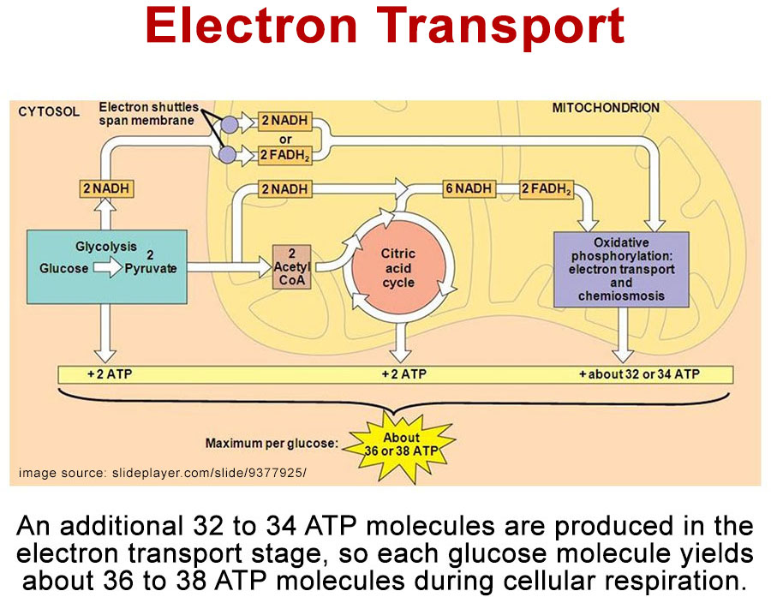

Total ATP Yield from One Glucose Molecule
Stage | ATP Produced (Direct) | ATP from NADH | ATP from FADH₂
Glycolysis | 2 ATP (net) | 2 NADH → ~5 ATP | 0
Acetyl CoA formation | 0 | 2 NADH → ~5 ATP | 0
Citric acid cycle | 2 ATP | 6 NADH → ~15 ATP | 2 FADH₂ → ~3 ATP
Electron transport chain | 0 | (included above) | (included above)
TOTAL | 4 ATP | ~25 ATP | ~3 ATP
GRAND TOTAL |  | ~32-34 ATP per glucose

Part 5: Aerobic vs. Anaerobic Respiration
Aerobic respiration requires oxygen. Anaerobic respiration (fermentation) occurs without oxygen. They differ in steps, ATP production, and byproducts.

Comparison of Aerobic and Anaerobic Respiration
Feature | Aerobic Respiration | Anaerobic Respiration (Fermentation)
Oxygen required? | Yes | No
Location | Cytoplasm + mitochondria | Cytoplasm only
Steps | Glycolysis → Acetyl CoA → Citric acid cycle → ETC + chemiosmosis | Glycolysis only, then fermentation to  regenerate NAD⁺
ATP produced per glucose | ~32-34 ATP | 2 ATP (net)
Byproducts | CO₂ and H₂O | Lactic acid (animals) or ethanol + CO₂  (yeast, plants)
Efficiency | Very high (captures ~34% of glucose's energy) | Very low (captures only ~2% of  glucose's energy)
Where it occurs | Most eukaryotic cells (with oxygen present) | Muscle cells (during intense exercise),  yeast, some bacteria

Anaerobic Respiration (Fermentation) in Detail
When oxygen is absent, the electron transport chain cannot function. NADH cannot be converted back to NAD⁺. Without NAD⁺, glycolysis stops. Fermentation solves this problem by regenerating NAD⁺.
Type of Fermentation | Organisms | Process | Byproducts
Lactic acid fermentation | Animal muscle cells (during intense exercise), some bacteria | Pyruvate → lactate (lactic acid), NADH → NAD⁺ | Lactic acid
Alcoholic fermentation | Yeast, some plants, some bacteria | Pyruvate → ethanol + CO₂, NADH → NAD⁺ | Ethanol + CO₂

Why Anaerobic Respiration Produces Less ATP
Reason | Explanation
No electron transport chain | Without ETC, most of the energy in glucose remains in the bonds  of pyruvate (or fermentation byproducts)
No citric acid cycle | Acetyl CoA cannot be processed without NAD⁺ and FAD  regenerated by ETC
Glycolysis only | Only 2 ATP are captured directly from substrate-level  phosphorylation in glycolysis

Part 6: How Cellular Respiration Provides Energy for Everyday Activities
Scientists use various sources of information — including exercise physiology studies, metabolic rate measurements, and clinical observations — to understand how cellular respiration powers daily life. The evidence shows that different activities demand different amounts of ATP, which are supplied by aerobic or anaerobic respiration depending on intensity and duration.

ATP Demand for Everyday Activities
Activity | Primary Energy System | ATP Demand | Explanation
Sleeping | Aerobic | Low | Body is at rest; ATP used for basal metabolism (heartbeat, breathing, cell repair, brain function)
Thinking (brain activity) | Aerobic | Moderate | The brain uses ~20% of the body's total ATP despite being only 2% of body mass
Digesting food | Aerobic | Low to moderate | Smooth muscle contractions, enzyme production, and nutrient absorption require ATP
Walking | Aerobic | Moderate | Leg muscles use aerobic respiration for sustained activity
Running (jogging) | Aerobic | High | Steady supply of oxygen supports continuous ATP production
Sprinting (all-out) | Anaerobic (lactic acid) | Very high (fast) | Oxygen cannot be delivered fast enough; muscles rely on glycolysis + lactic acid fermentation
Weight lifting | Anaerobic (lactic acid) | Very high (brief) | Short, intense bursts of activity use stored ATP and anaerobic pathways

How Scientists Study Cellular Respiration in Humans
Source of Information | What It Tells Us
VO₂ max testing (maximum oxygen consumption) | Measures the maximum rate of aerobic respiration  during intense exercise
Blood lactate measurements | Indicates when muscles switch from aerobic to  anaerobic respiration (lactate threshold)
Respiratory exchange ratio (CO₂ produced / O₂ consumed) | Reveals which fuel (carbohydrates vs. fats) is being  used for ATP production
Calorimetry (measuring heat production) | Directly measures energy expenditure because  cellular respiration releases heat
Heart rate monitoring | Heart rate correlates with oxygen delivery

Examples of Cellular Respiration Powering Daily Life
Activity | How Cellular Respiration Powers It
Running a marathon | Leg muscles use aerobic respiration to produce ATP continuously  over hours; fatty acids and glucose are broken down with oxygen
Sprinting 100 meters | Muscles use anaerobic respiration (lactic acid fermentation) because  oxygen delivery cannot keep up; ATP is produced rapidly but only  for 10-15 seconds
Thinking and studying | Brain neurons use aerobic respiration exclusively; glucose is the  primary fuel; ATP powers ion pumps that maintain nerve signals
Digesting a meal | Smooth muscle cells in the stomach and intestines use aerobic  respiration to contract and move food; enzyme-producing cells use  ATP to synthesize and secrete digestive enzymes
Recovering after exercise | The body continues aerobic respiration at an elevated rate to repay  oxygen debt, convert lactic acid back to glucose, and replenish  ATP stores

Real-World Connection: Why You Breathe Heavily After Sprinting
After intense anaerobic exercise, you continue breathing heavily even though you have stopped moving. This is called excess post-exercise oxygen consumption (EPOC). The extra oxygen is used for:
Use of Oxygen After Exercise | Purpose
Convert lactic acid back to glucose (in the liver) | Requires ATP (made aerobically)
Replenish ATP stores in muscles | Aerobic respiration

Replenish oxygen stored in hemoglobin and myoglobin | Restoring oxygen reserves
Return body temperature to normal | Heat from metabolism must be  balanced

Key Terms
Term | Definition
Cellular respiration | The chemical reaction that converts chemical energy (glucose)  into usable energy (ATP)
ATP | Adenosine triphosphate; the energy currency of the cell
Aerobic respiration | Respiration that requires oxygen; produces ~32-34 ATP per  glucose
Anaerobic respiration (fermentation) | Respiration without oxygen; produces only 2 ATP per glucose
Glycolysis | First stage of respiration; occurs in cytoplasm; splits glucose  into two pyruvate molecules
Acetyl CoA | Two-carbon molecule formed from pyruvate; enters the citric  acid cycle
Citric acid cycle (Krebs cycle) | Second stage of aerobic respiration; occurs in mitochondrial  matrix; produces NADH, FADH₂, CO₂, and ATP
Electron transport chain (ETC) | Series of proteins in the inner mitochondrial membrane; transfers  electrons and pumps protons
Chemiosmosis | Process using proton gradient to drive ATP synthesis via ATP  synthase
Mitochondria | Organelle where aerobic respiration occurs (except glycolysis)
Cristae | Folds of the inner mitochondrial membrane; increase surface  area for ETC
Matrix | Fluid-filled inner compartment of mitochondria; contains citric  acid cycle enzymes
NADH and FADH₂ | Electron carriers that deliver electrons to the electron transport  chain
Lactic acid fermentation | Anaerobic respiration in animal muscles; produces lactic acid
Alcoholic fermentation | Anaerobic respiration in yeast and some plants; produces  ethanol and CO₂

Review Questions
1. In your own words, explain what cellular respiration is. Your answer must state that cellular respiration converts chemical energy into usable forms of energy (ATP).
2. Draw a labeled diagram showing the four main stages of aerobic respiration: glycolysis, formation of acetyl coenzyme A, the citric acid cycle, and the electron transport chain with chemiosmosis. Your diagram must include the location of each stage and the inputs and outputs of each stage.
3. Describe what happens during glycolysis. Include the location, whether oxygen is required, the input molecule, and the outputs (net ATP, NADH, and pyruvate).
4. Describe what happens during the formation of acetyl coenzyme A. Include the location, the input molecule, the outputs, and why this step is considered a connecting step between glycolysis and the citric acid cycle.
5. Describe what happens during the citric acid cycle (Krebs cycle). Include the location, the input molecule, the outputs (per glucose molecule), and the fate of the carbon atoms.
6. Describe what happens during the electron transport chain and chemiosmosis. Include the location, the role of oxygen, how a proton gradient is created, how ATP synthase uses the gradient to make ATP, and the final products.
7. Explain the importance of ATP as the energy carrier in cells. Your answer must describe the structure of ATP (three phosphates), how it releases energy (ATP → ADP + Pᵢ), and how it is recycled.
8. Explain the role of enzymes in cellular respiration. Your answer must state that enzymes lower activation energy, are specific to each reaction, and are regulated by feedback inhibition.
9. Describe how the structure of mitochondria relates to their function in cellular respiration. Your answer must include the following structures and explain how each supports respiration: outer membrane, inner membrane, cristae, matrix, and intermembrane space.
10. Differentiate between aerobic and anaerobic respiration. Complete the following comparison in your answer:
Feature | Aerobic Respiration | Anaerobic Respiration (Fermentation)
Oxygen required?
Location in cell
Steps (list main stages)
ATP produced per glucose
Byproducts
11. Using information from secondary sources, explain how cellular respiration provides energy for everyday activities. Your answer must include specific examples for each of the following activities: running (sprinting vs. marathon), thinking, and digesting food. For each activity, state whether aerobic or anaerobic respiration is primarily used and why.
12. Application question: A runner completes a 400-meter sprint and then rests. During the sprint, the runner's muscles used anaerobic respiration. After the sprint, the runner continues breathing heavily for several minutes. Explain why the runner continues to breathe heavily after stopping. Use the terms oxygen debt (EPOC), lactic acid, and aerobic respiration in your answer.

